Worksheet No. – 04

Aim/Overview of the practical: To calculate the total order amount for each customer using LEFT JOIN, GROUP BY, SUM(), and COALESCE(), including customers who have not placed any orders.
Objective: To calculate and display the total order amount for each customer using LEFT JOIN, GROUP BY, SUM(), and COALESCE(), including customers who have not placed any orders by displaying their total as 0.

PROCEDURE
- Create Customers and Orders tables.
- Insert customer and order records.
- Use LEFT JOIN to connect customers with their orders.
- Use SUM() to calculate the total order amount.
- Use GROUP BY to group orders customer-wise.
- Use COALESCE() to display 0 for customers with no orders.
- Execute the query and verify the results.
Code:
CREATE DATABASE ACD;
USE ACD;

-- Create Customers table
CREATE TABLE Customers (
customer_id INT PRIMARY KEY,
customer_name VARCHAR(50)
);

-- Insert customer data
INSERT INTO Customers VALUES
(1, 'Rahul'),
(2, 'Priya'),
(3, 'Aman'),
(4, 'Neha');

-- Create Orders table
CREATE TABLE Orders (
order_id INT PRIMARY KEY,
customer_id INT,
order_amount DECIMAL(10,2),
FOREIGN KEY (customer_id) REFERENCES Customers(customer_id)
);
-- Insert order data
INSERT INTO Orders VALUES
(101, 1, 2000),
(102, 1, 1000),
(103, 2, 3000),
(104, 3, 1500);
-- Calculate total order amount for each customer
SELECT
c.customer_id,
c.customer_name,
COALESCE(SUM(o.order_amount), 0) AS total_order_amount
FROM Customers c
LEFT JOIN Orders o
ON c.customer_id = o.customer_id
GROUP BY
c.customer_id,
c.customer_name;
OUTPUT
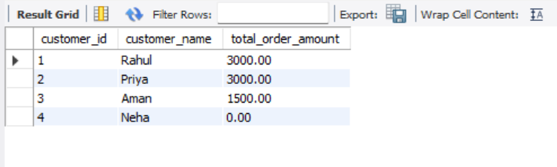
Learning Outcome:
- Understood the use of LEFT JOIN in SQL.
- Learnt to calculate totals using SUM().
- Understood GROUP BY for grouping customer records.
- Learnt to handle NULL values using COALESCE().
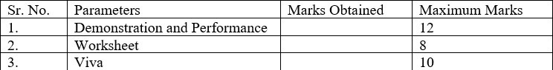
Evaluation Grid:

